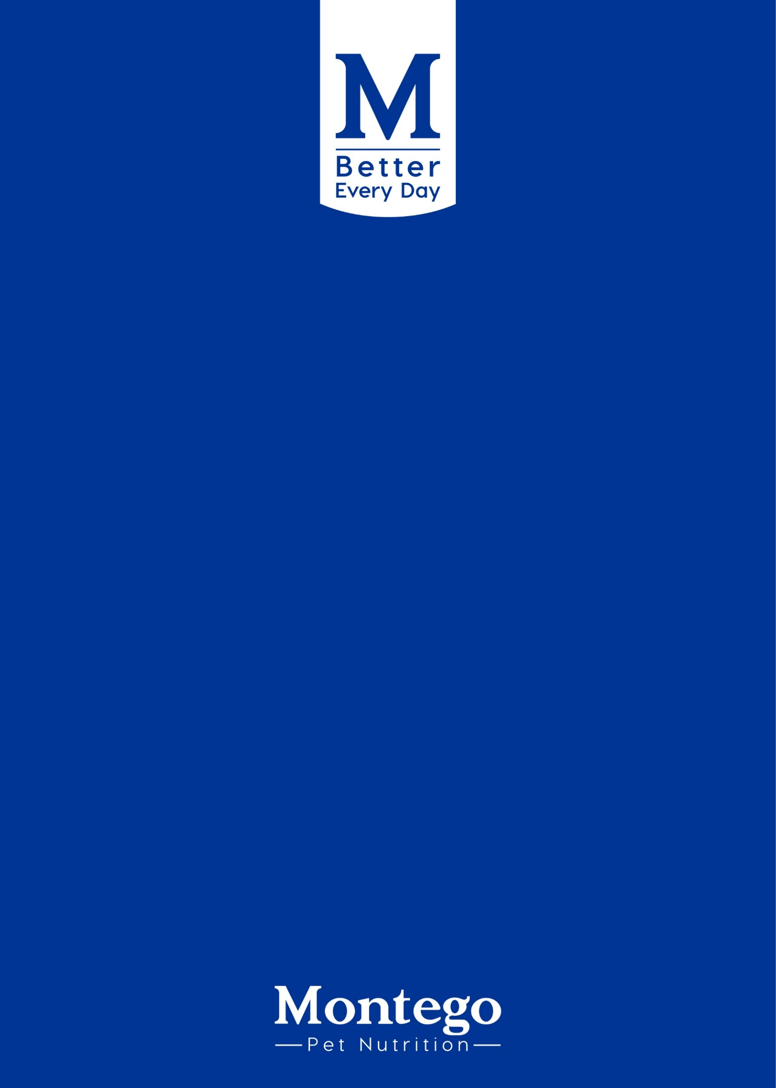

TARDINESS, LOITERING, AND

TIME-WASTING POLICY

Contents
1. PURPOSE 2
2. SCOPE 2
3. DEFINITIONS. 2
4. POLICY GUIDELINES 3
5. SMOKING AND VAPING 4
6. MOBILE DEVICES 4
7. ALIGNMENT WITH APPLICABLE POLICIES AND LEGISLATION 5
8. RESPONSIBILITIES 5
9. NON-COMPLIANCE 5
10. QUERIES 5

PURPOSE
This policy establishes clear guidelines to address workplace tardiness, loitering and time-wasting. It aims to promote productivity, punctuality and a professional work environment in compliance with the Basic Conditions of Employment Act (BCEA) and all applicable South African labour laws..

SCOPE
This policy applies to all employees of Montego Pet Nutrition, regardless of whether they work on-site at any Montego premises, remotely or in a hybrid capacity.

DEFINITIONS.
Authorised Personnel | Employees who have received explicit permission from management to access restricted areas or engage in activities not available to all employees.
Break Time | The period during which employees are permitted to rest or attend to personal matters in line with their work schedule, whether on-site or working remotely.
Designated Rest Areas | Specific areas within company premises or approved remote workspaces are allocated for employees to take breaks, eat or relax during scheduled break times.
Inactivity | Periods during which employees are not engaged in productive work tasks, including idle or unproductive behaviour, whether on-site or remotely.
Loitering | Remaining idle or lingering in any work setting, physical or virtual, without a valid work-related purpose or prior authorisation.
Meal Interval | A continuous break of at least 30 minutes after no more than five hours of work, as required by the Basic Conditions of Employment Act.
Mobile Device | Any personal electronic device such as a smartphone, tablet or laptop used by employees for communication, accessing information or performing work-related or personal tasks.
Non-Work-Related Activities | Personal activities not related to the employee’s duties, including social conversations, personal phone calls, non-work-related internet browsing or other activities during working hours.
Productivity | The measure of how effectively employees complete their assigned duties and responsibilities within designated working hours.
Remote Work | Work performed by employees from a location other than the Montego premises, including a home office or any other approved location.
Restroom and Kitchen Use | Access to facilities intended for personal needs or meals, which must not be used for extended breaks or as unapproved workspaces.
Tardiness | Failure to commence work or attend work-related activities at the agreed start time without a valid reason, thereby affecting productivity.
Time-Wasting | Engaging in any activity during working hours that detracts from the performance of assigned duties, including personal use of mobile devices, social media or non-work-related discussions.
Unapproved Areas | Areas within Montego premises or virtual environments where employees may not spend time unless performing work-related tasks or with prior authorisation.
Work Area | Any physical or virtual environment where employees are required to perform their duties, including offices, production sites, warehouses, designated remote workspaces and digital platforms.
Working Hours | The period during which employees are required to perform work, excluding any authorised meal intervals or breaks, in line with contractual obligations and applicable law.

POLICY GUIDELINES
This section outlines acceptable and unacceptable behaviours related to arriving late, spending time away from designated work areas without authorisation, engaging in personal activities during work time, and using mobile devices.
  - Tardiness
- Employees are required to be ready to commence work at their scheduled start time, whether working on-site, remotely or in a hybrid capacity.
- Employees are encouraged to log in or clock in a few minutes before their shift begins to ensure readiness.
- For designated staff responsible for shift handovers, this preparation period shall be recognised as part of paid working hours.
- Repeated tardiness will be managed through the company’s progressive disciplinary process.

  - Loitering
Employees must stay in their designated work areas or be involved in approved work-related tasks throughout working hours. Leaving workstations, not responding to work requirements while working remotely, or taking unauthorised breaks will be considered loitering. Employees are expected to dedicate their full working time and attention to company duties and must not participate in non-work-related activities during working hours.

  - Time wasting
Employees are expected to devote working hours to their assigned duties. Using mobile devices or computers for personal activities is permitted only during designated break times. Prolonged personal conversations, browsing the internet for non-work-related purposes or similar activities will be treated as time-wasting.
In production, warehouse, and depot environments, any behaviour that distracts from duties or creates unnecessary congestion or inattentiveness will be considered a health and safety risk in addition to a productivity concern.

SMOKING AND VAPING
- Smoking and vaping are prohibited in all Montego Pet Nutrition working environments, including home offices during virtual meetings or calls, except in designated smoking areas or scheduled break times.
- Employees may not take smoke breaks simultaneously within the same department to maintain operational continuity. Smoke breaks may be taken during lunch or at other agreed intervals, subject to prior approval from the relevant supervisor or manager.

MOBILE DEVICES
  - Employees who bring personal mobile devices to work or use them while working remotely do so at their own risk. During working hours, mobile devices must be used exclusively for work-related communication, except during designated break times.

  - The use of mobile devices is strictly prohibited in all production, factory and depot areas where such use may pose a health or safety hazard, interfere with equipment, or compromise operational security. This prohibition includes, but is not limited to, talking on the phone, texting, browsing the internet, taking photographs, recording video or audio, or charging devices in these environments.

  - Employees are only permitted to use mobile devices in these areas if:

    - They have explicit written authorisation from their manager or supervisor for a specific operational purpose.
    - They comply fully with all safety protocols, signage and instructions relating to equipment and production safety.
    - The use does not interfere with safe work practices or the safety of other employees.
    - Any breach of these provisions will be regarded as a serious violation of safety protocols and will be addressed in line with the Employee Relations and Disciplinary Guidelines Policy and the Occupational Health and Safety Act, No. 85 of 1993. Repeated or severe breaches may result in disciplinary action up to and including dismissal.
    - Employees working in office-based or approved remote locations are expected to use mobile devices responsibly and only in safe, designated spaces.

ALIGNMENT WITH APPLICABLE POLICIES AND LEGISLATION
This policy has been developed in alignment with the following Montego Pet Nutrition policies and applicable South African legislation:
- Employee Relations and Disciplinary Guidelines Policy
- Remote Work Policy
- Hybrid Work Policy
- Overtime Policy
- Smoking and Vaping Policy
- Code of Conduct
- Basic Conditions of Employment Act, No. 75 of 1997
- Labour Relations Act, No. 66 of 1995
- Occupational Health and Safety Act, No. 85 of 1993
- Tobacco Products Control Act, No. 83 of 1993
Employees are reminded that no provision in this policy limits their statutory rights under any applicable legislation. This policy must be read together with the policies mentioned above to ensure a consistent and fair application of standards across the organisation.

RESPONSIBILITIES
- Employees are responsible for complying with all provisions of this policy, including maintaining punctuality, productivity, appropriate use of work time and areas, and adherence to all related health and safety requirements. Employees must ensure that their conduct at all times supports a professional, safe and efficient work environment, whether working on-site, remotely or in a hybrid capacity.
- Supervisors and managers are responsible for monitoring compliance with this policy in its entirety, including time management, presence in authorised work areas, appropriate use of mobile devices, and adherence to safety protocols. Managers must also ensure that any breaches are addressed promptly, consistently and fairly, in line with the Employee Relations and Disciplinary Guidelines Policy and applicable legislation.

NON-COMPLIANCE
Non-compliance with this policy will be addressed through the progressive disciplinary process in accordance with the company’s Disciplinary Code and Procedure. Disciplinary action may range from counselling and verbal warnings to written warnings, suspension or termination, depending on the seriousness and recurrence of the breach. Any violation of this policy that also constitutes a breach of health and safety obligations will be regarded as serious misconduct and may warrant more severe disciplinary measures.

QUERIES
All queries should be referred to the Human Resources Department for clarification.

